Penny Investigation
Materials:
100 Pennies
Cup
TI-83 Graphing Calculator

Steps:
- In your group of two, open rolls of pennies and put the 100 pennies into your cup.
- Shake up pennies and pour them onto the table.
- Separate the pennies into Heads or Tails
- Choose either Heads or Tails to count and discard the other.
- Once you’ve counted, record data and put remaining pennies back in your cup and repeat the process with the remaining pennies.
- Continue until all pennies are eliminated

Data:
Toss # | Pennies  Remaining | Toss # | Pennies  Remaining | Toss # | Pennies  Remaining

Create a graph below:

**Once all data has been collected and graph has been made, follow the directions on how to input your data in the TI-83 graphing calculator.

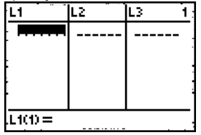
Step 1: Press STAT; Press 1 (Edit)

Step 2: Begin entering data in L₁ (Toss #1) and then L₂ (Pennies Remaining)

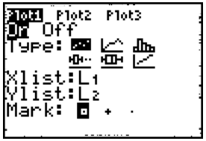

Step 3: Press 2nd STAT PLOT; Press 1 (Plot 1) ; Put cursor on ON and enter.

Step 4: Press ZOOM; Press 9 (ZoomStat) and a graph will appear.

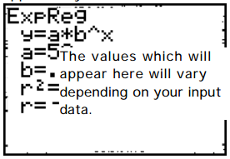
Step 5: To find the best-fit graph: Press STAT; Press CALC; Press 0 (ExpReg); The word “ExpReg” will appear on the screen. Press ENTER. You will see the following.

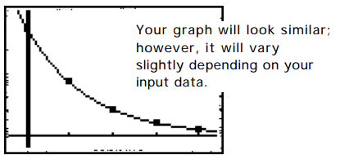
Step 6: Press Y=; Press VARS; Press 5 (Statistics); arrow over to EQ and Press 1 (RegEq). This will return you to the Y= screen with an exponential equation. Press GRAPH.

- Will your data look different from another group if they decided to discard a different penny, for example, you decided to count heads and they decided to count tails?

- What is your exponential equation given on the calculator?

- What does the “a” represent?

- What does the “b” represent?

- What is your r² value and what does it mean?

- What is the mathematical model for exponential decay?

- Explain why your equation does/ does not match the mathematical model.

- What would allow your exponential equation to approach the mathematical model?

